* **Title of the seminar**: Career Opportunities in Scientific Fish Farming and Government Scheme
* **Type of the Activity**: Seminar on Entrepreneurship
* **Organizing Department/ Committee:** CAREER COUNSELING CELL
* **Date of the Activity:** 06-01-2023
* **Number of participants:** 93
* **Speakers:** Sri Pradip Roy, FEO Chakdaha Block, and Sri Subhendu Halder, AFO, Nadia
* **Objective of the programme:** The objective of the career talk is to enlighten individuals about the promising career opportunities in scientific fish farming and create awareness about the various government schemes and initiatives that support and promote the fisheries sector. The talk aims to inspire participants to consider fish farming as a rewarding and sustainable career choice and equip them with information on government schemes to help them venture into this field successfully.
* **Outcomes of the programme:**

1. Participants gained insights into the concept of scientific fish farming, including modern aquaculture techniques and sustainable approaches for fish production.
2. The career talk highlights the diverse career opportunities available in the fisheries sector, including fish farm management, fish feed production, and fish health management.
3. Students learned about the skills and knowledge required to excel in scientific fish farming, such as fish biology, water quality management, disease prevention, and farm operation management.
4. The talk provides information on various government schemes and financial assistance available for aspiring fish farmers, encouraging them to leverage these resources to start their ventures.

* **Relevant Link:**

<https://www.facebook.com/chakdahacollegeoffice/posts/pfbid02FzNnUocUXwA1FZpfGcvC1qAiAgG3mc54fMpFY92WTmWa9xYit3f84yySasWoz1gKl>

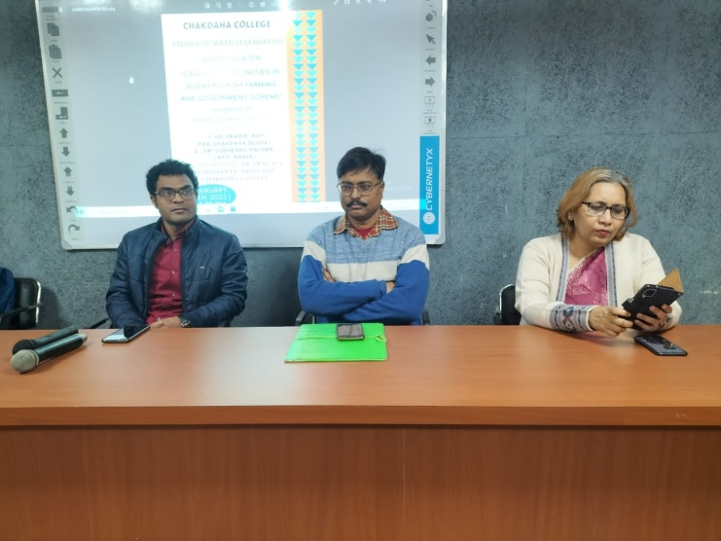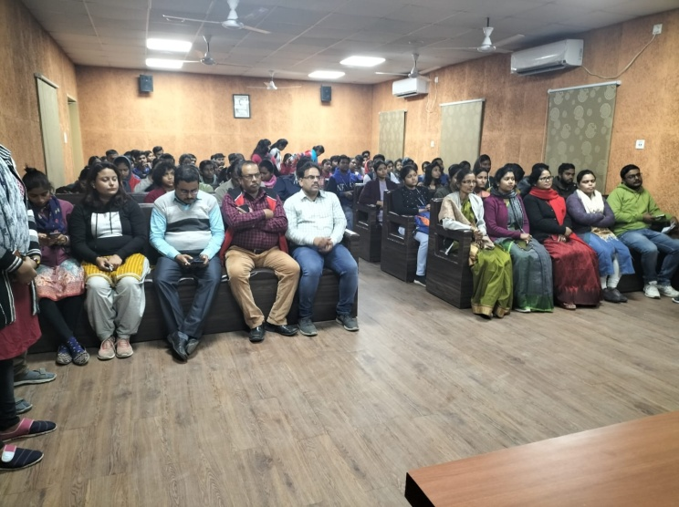

Distinguish dignitaries of the Seminar Audience of the Seminar

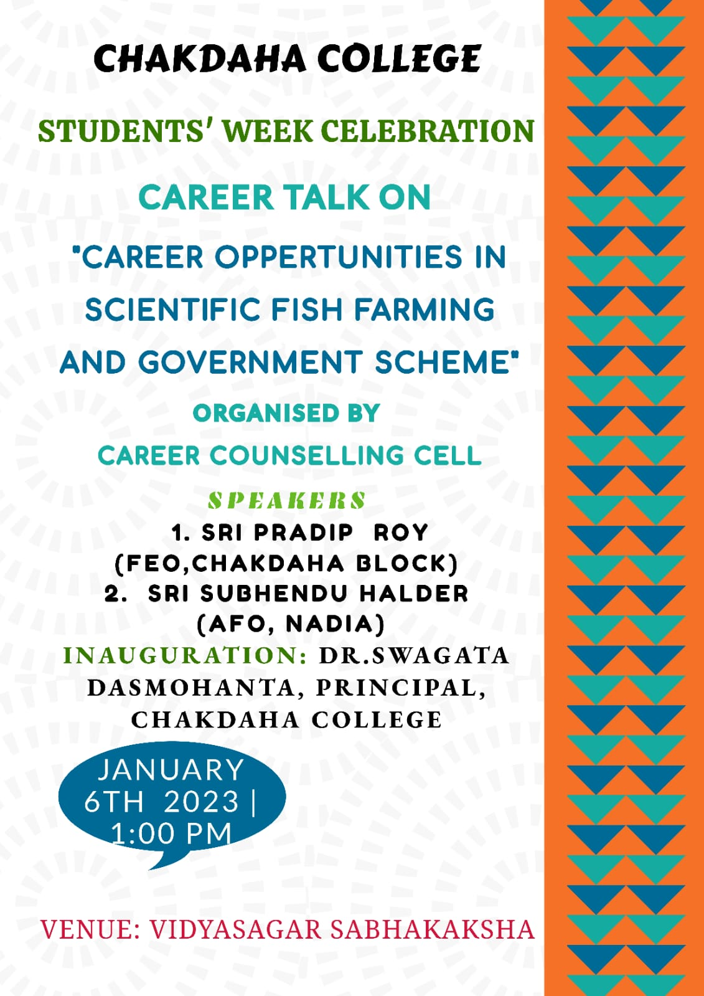

***Attendance***

